Compass Survey Application

# Solution Design:

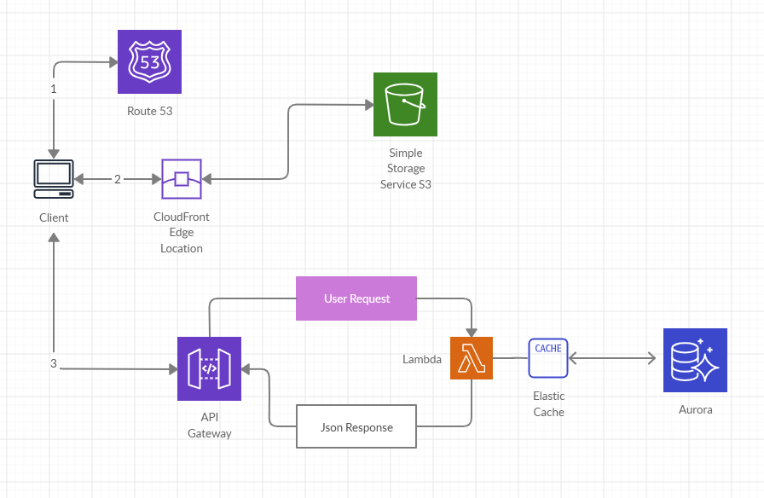

# Technology to Use:

1. Route 53 (DNS)
2. S3 (Static File Hosting)
3. CloudFront (Global distribution)
4. API Gateway (Serving API)
5. Lambda (Compute)
6. Elastic Cache (Caching)
7. Aurora (Database)
8. Nodejs with Typescript (Programing Language)
9. Jest (Testing)

# API Design:

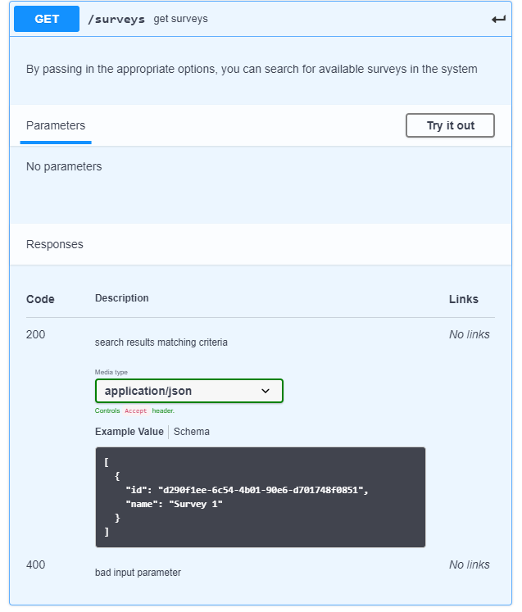

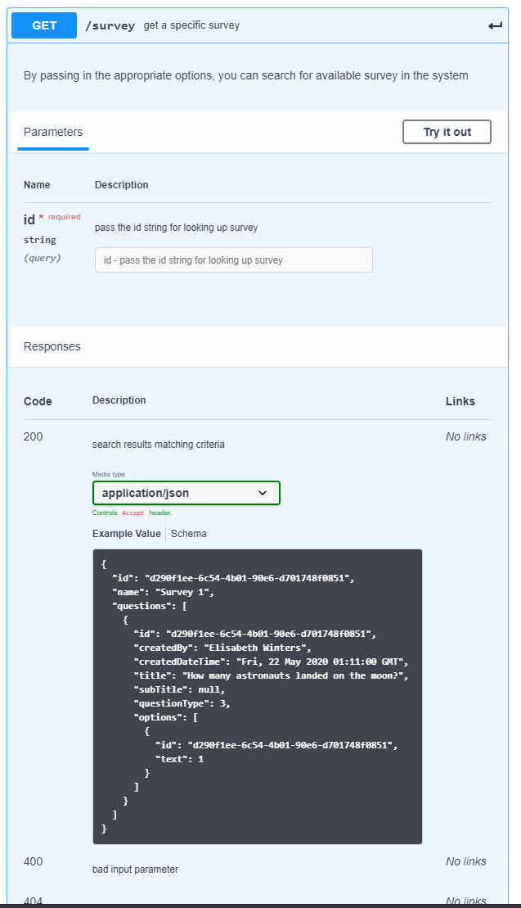

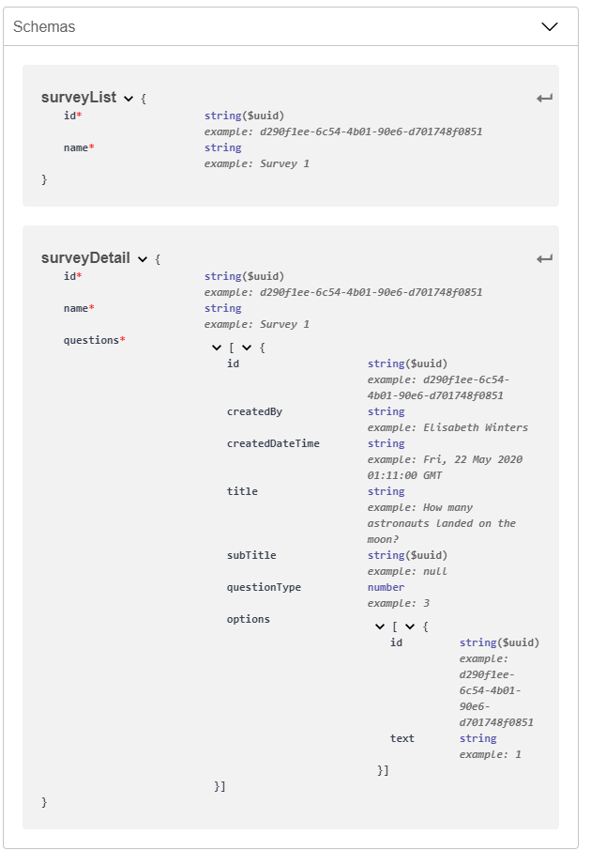

# SQL Design:

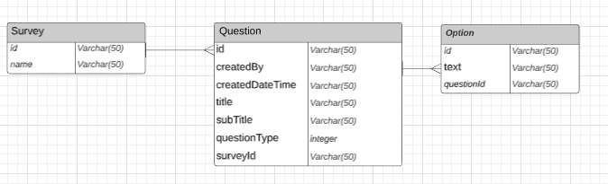

# Directory Structure:

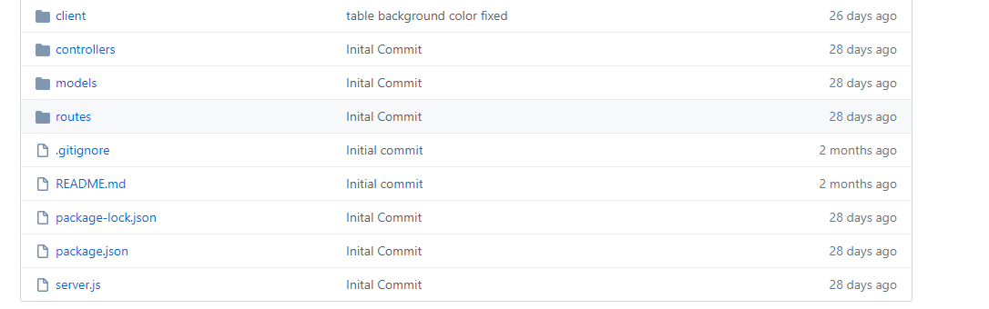

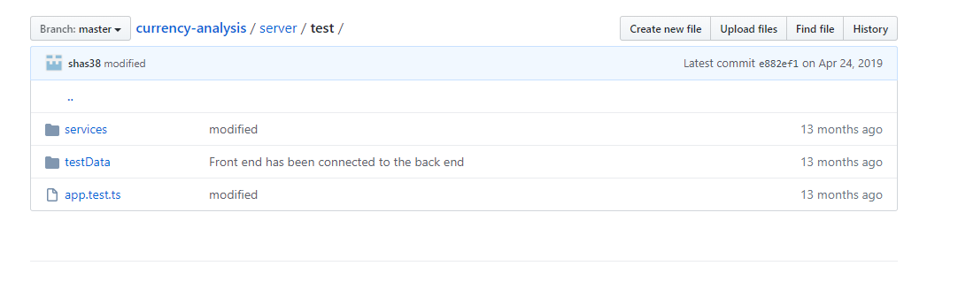

# Test Design:

Please visit <https://github.com/shas38/currency-analysis/tree/master/server/test> for sample test design.